**SHUFFLE GAME**

**About the shuffle game:**

This program is good example of using graphics concept to develop an application using C++. Under this game a number game has been prepared by which users will able to get graphical mode on command line interface. Users will have to just run the program and program will guide the users how to play the game and exit from it. In order to run the program users have to first give the proper path of the graphics driver which is available under bgi. To check the whether graphics driver is available or not, you have to quit the turbo c++ shell and you will be taken to the C:\TURBOC3\BIN. You will have to change the directory to check whether bgi driver is available or not. So you can change directory by CD... and press enter. After changing the directory you will be taken to C:\TURBOC3\ after which you will have to go to next directory by entering C:\TURBOC3\BGI and press enter to check whether bgi graphics driver is available. If available then only this program will run successfully. The directory of bgi can be different as per the compiler you are using. This is the path of the graphics driver which you have to give in this program to enjoy the shuffle game. Once this program has been run successfully, you will get the welcome page of the shuffle game as below:-

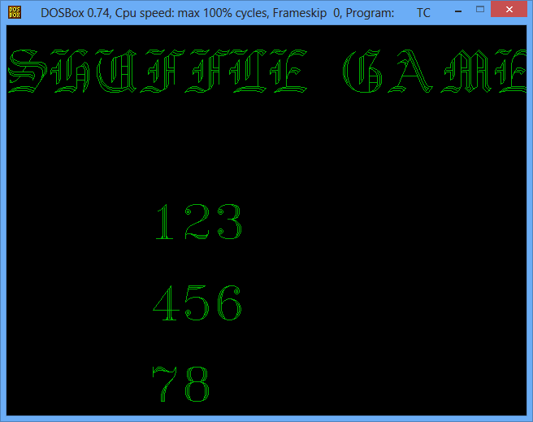

To start this game, you have to press any key, for few seconds the color of the written texts in graphics will change in different colors and it will be redirected to the next section. In the next section you will be given choice for making your selection. There will be two types of option. Option 1 will be to play the game and option 2 will be the instruction which you have to follow while playing this game.

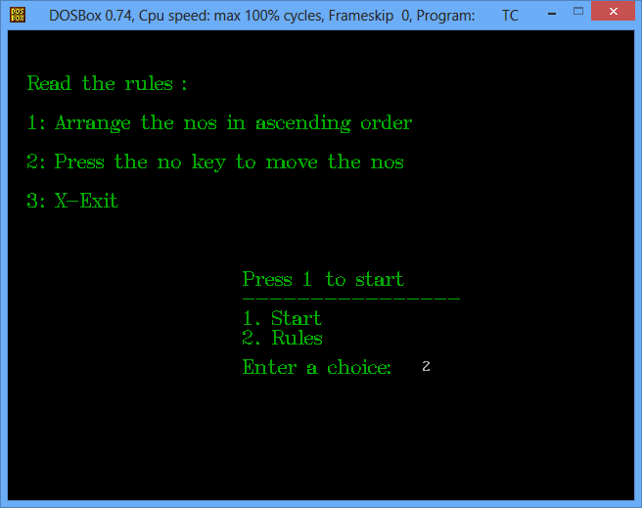  
If you will press 2, the instruction will be shown on the above screen and if you will press 1 its screen will change and redirected to next section where you have to play the game by moving the numbers. You have to press number which you want to move and use arrow keys to move the particular number to the desired location.

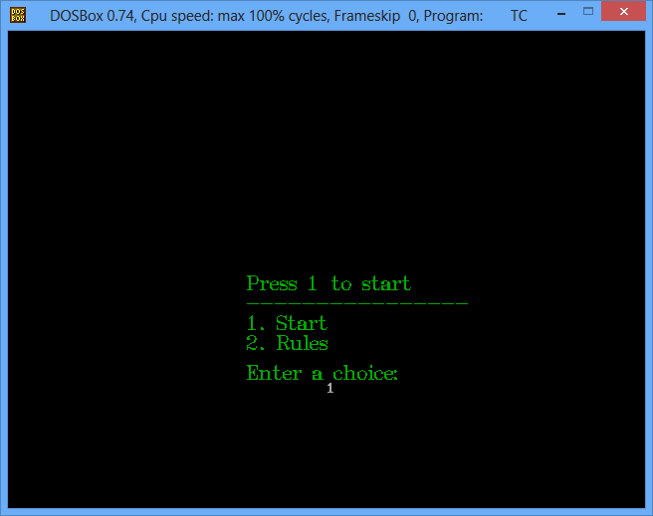

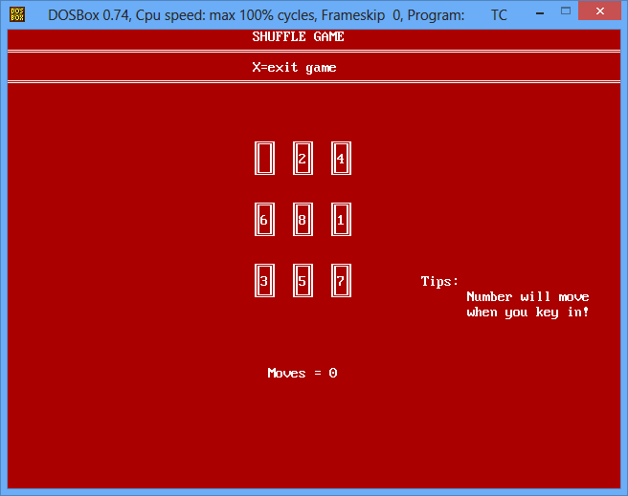

One the game has been started you can quit the game anytime by pressing X character. Once this character has been entered, you will taken out from the game.